

**SCHOOL VISIT BOOKING FORM**

**School Visit Booking**

* Booking requests must be made **at least 5 weeks prior to your visit**. Kindly visit [our website](https://www.singaporeartmuseum.sg/) to better understand SAM’s current, ongoing exhibitions and offerings.
* Complete and email this form to [**learning@singaporeartmuseum.sg**](mailto:learning@singaporeartmuseum.sg).
* Your email subject should include “**School Visit Booking**” and your **school's name**.
* **All educational visits are confirmed only upon email notification from SAM**.

**Pre-Visits**

* Booking of School Visit:
  + Teacher(s) to fill in and submit the form to [**learning@singaporeartmuseum.sg**](mailto:learning@singaporeartmuseum.sg) 5 weeks prior to the visit.
  + Teacher(s) to receive the email confirmation from SAM’s Learning team for all visits.

**Teachers should ensure the following prior to the visit:**

* + Brief students on **museum etiquette**, found on the following page;
  + Students should **leave their school bags in school** and bring a **small tote bag** to keep their pencil, sketchbook or worksheet (if applicable);
  + Students are not allowed to bring and consume their own food within the gallery;
  + Water bottles are allowed at TPD but not allowed when entering the gallery;
  + Students are encouraged to **use the toilet in schools** prior to boarding the bus;
  + Schools may drop off at:
    - Rear Entrance (facing Keppel Terminal), Blk 39 Keppel Road, #01-02 at Tanjong Pagar Distripark  
      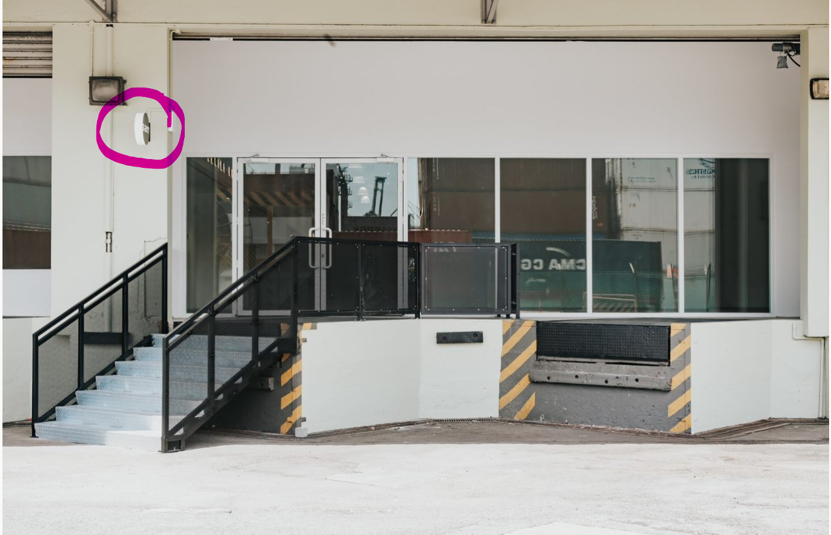 A black wall with white letters on it

      Description automatically generated

**OTHER NOTES FOR TEACHERS**

* Teachers or accompanying adults should be with the students at all times to maintain discipline and keep noise levels conducive to all visitors for their enjoyment of the artworks.
* The school will be held responsible for any misconduct and damage incurred during their visit to the museum, with the possibility of forgoing their guided tour privileges for the rest of the year.
* Singapore Art Museum makes no representations or warranties in relation of any kind relating to the contents of the resource, and any use or reliance on the same by you is solely at your own risk. Singapore Art Museum shall not be liable to you or any third party for any consequences, damage or loss whatsoever and howsoever caused arising directly or indirectly from your or any third party’s use of the contents.

***I have read and understood the above terms and conditions.***

***My students will leave their bulky school bags in school.***

**MUSEUM ETIQUETTE**

|  |
| --- |
| **5 things to take note of:** |
| **5 things to do:** |

***My students will be briefed on the museum etiquette before their visit to the museum.***

**SCHOOL VISIT BOOKING FORM**

* Email this form and the questionnaire to [**learning@singaporeartmuseum.sg**](mailto:learning@singaporeartmuseum.sg). Your email subject should include “School Visit Booking” and your school's name.
* **All school visits are confirmed only upon email notification from SAM**.

***I have read and understood all the terms and conditions in the School Visit Booking Form.***

|  |  |
| --- | --- |
| Teacher-In-Charge: | Email:  *I do not wish to join the mailing list for educators.* |
| Office Tel: | Mobile No: |
| School Name: | School Tel: |

**._**

|  |
| --- |
| **Number of students:** Click or tap here to enter text. **Level:** Click or tap here to enter text.  **Class(es):** Click or tap here to enter text. |
| **Name** and **Mobile Number** of teacher(s) accompanying the students for the visit:  Click or tap here to enter text. (Please contact **SAM Learning at 66979776** if your group encounters any issues on-route to location.) |

|  |  |
| --- | --- |
| **TYPE OF VISIT**  Self-directed Visit  Guided Visit *(subject to availability)* | |
| |  |  | | --- | --- | | **LOCATION:** | **EXHIBITION(S)/ ARTWORK(S):** | | **Side Entrance,**  **Tanjong Pagar Distripark** Level 1, along Keppel Road | Ongoing till 31 December 2024  [**Public Art**](https://www.singaporeartmuseum.sg/art-events/exhibitions/the-everyday-museum-at-tanjong-pagar-distripark)   * [*Creatif Compleks*](https://www.theeverydaymuseum.sg/artwork/creatif-compleks/) | | **SAM at Tanjong Pagar Distripark** Blk 39 Keppel Rd, #01-02 | Ongoing till 25 February 2024  [***Proof of Personhood: Identity and Authenticity in the Face of Artificial Intelligence***](https://www.singaporeartmuseum.sg/art-events/exhibitions/proof-of-personhood) Gallery 3, #03-05  *Some artworks may contain mature graphics and language.*  Ongoing till 3 March 2024  [***Ho Tzu Nyen: Time & the Tiger***](https://www.singaporeartmuseum.sg/Art-Events/Exhibitions/Ho-Tzu-Nyen-Time-and-the-Tiger) Gallery 1 & 2, #01-02 *This exhibition features loud sounds, flashing lights, smoke machines and mature themes. Due to dim lighting, please remind your students to walk carefully through the exhibition.*  Ongoing till 14 April 2024  [***47 Days, Sound-less***](https://www.singaporeartmuseum.sg/art-events/exhibitions/47-days-sound-less) The Engine Room  Ongoing till 31 December 2024  [**Public Art**](https://www.singaporeartmuseum.sg/art-events/exhibitions/the-everyday-museum-at-tanjong-pagar-distripark)  Various Locations around Blk 39   * [*Prove You Are Human*](https://www.theeverydaymuseum.sg/artwork/prove-you-are-human/) * [*The Oort Cloud and the Blue Mountain: Edition Tanjong Pagar Distripark*](https://www.theeverydaymuseum.sg/artwork/the-oort-cloud-and-the-blue-mountain/) * [*Sea of flags*](https://www.theeverydaymuseum.sg/artwork/sea-of-flags/)(Ongoing till 9 March 2025) | | **Blk 37, SAM at Tanjong Pagar Distripark** Blk 37 Keppel Rd | Ongoing till 21 April 2024  [***Simryn Gill & Charles Lim Yi Yong: The Sea is a Field***](https://www.singaporeartmuseum.sg/art-events/exhibitions/the-sea-is-a-field) Block 37 |   Visit [our w](https://www.singaporeartmuseum.sg/art-events#exhibitions)ebsite for more information about the current exhibitions. \**For visits to other venues, please write to* [*learning@singaporeartmuseum.sg*](mailto:education@singaporeartmuseum.sg) | |
| Please indicate your preferred date(s) and timing(s) for your visit. | |
| **1st Choice for School Visit:** **Date of Visit:** Click or tap to enter a date. **Time of Visit:** Click or tap here to enter text.  Morning (between 10.30 am – 12.00 pm)   Afternoon (between 2.30 – 4.30 pm) | **2nd Choice for School Visit:** **Date of Visit:** Click or tap to enter a date. **Time of Visit:** Click or tap here to enter text.  Morning (between 10.30 am – 12.00 pm)  Afternoon (between 2.30 – 4.30 pm) |

***Please complete the next page as well***

**QUESTIONNAIRE FOR SCHOOL**

**Has your school brought students to SAM before?**

Yes, for:   
☐ Educational Workshop  Gallery Session  Guided Visit  Self-directed Visit   
 No

**Why did your school decide to bring your students to SAM? (Please select all that apply)**

Excursion

Art Club excursion   
 (Other CCAs, please specify: Click or tap here to enter text.)

For my students to familiarize themselves with SAM and learn museum-going etiquette

To support classroom learning about art

To enjoy and learn more about contemporary art through SAM’s exhibitions

Inter-disciplinary learning: learning another subject through art   
(Subject/ topic: Click or tap here to enter text.)

Others   
(please specify: Click or tap here to enter text.)

**Will teachers be using any teaching materials during the visit?**

Yes, my own teaching materials  Yes, materials from SAM  No

|  |
| --- |
| Please tell us more about your students: |
| Click or tap here to enter text. |

|  |
| --- |
| If there are special needs student(s), please let us know:  - number of special needs student  - diagnosis  - any special concerns we should take note of |
| Click or tap here to enter text. |

**Please note that all school visits are confirmed only upon email notification from SAM.**